California Case

# Market

The fleet of plug-in electric vehicles in the United States is the largest in the world, with a 43% share of global sales as of September 2014. Since 2008, about 260,000 highway legal plug-in electric cars have been sold in the country through the end of September 2014.[1] California accounts for about 40% of all plug-in cars sold in the country, with over 100,000 units sold through August 2014, and not only has more plug-in electric vehicles than any other American state but also more than any other country.[2]

As of December 2014, a total of 129,470 plug-in electric vehicles have been registered in California between December 2010 and December 2014, representing about 45% of all plug-in cars sold in the U.S. since 2010. During 2014 California's PEV market share reached 3.2% of total new car sales in the state, up from 2.5% in 2013, while the national PEV market share in 2014 was 0.71%. Registrations of plug-in electric cars in the state in 2014 represented 50.1% of total PEV sales in the U.S. that year.[3]

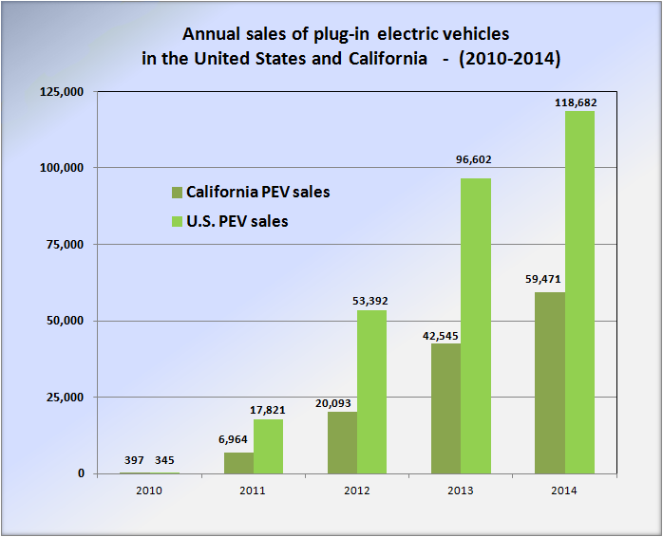

Comparison of annual sales of plug-in electric vehicles in the United States versus California between 2010 and 2014.[4]

**As of December 2014, California not only has more plug-in electric vehicles than any other American state but also more than any other country in the world.[5]**

California is the leading Volt market and accounted for almost 23% of Volt sales during the second quarter of 2012, followed by Michigan with 6.3% of national sales. The leading regional markets in California were San Francisco, Los Angeles, and San Diego.[6]

Governor Jerry Brown issued an executive order in March 2012 that established the goal of getting 1.5 million zero-emission vehicles (ZEVs) in California by 2025.[7]

California is the largest American market for the Tesla Model S.[8] In March 2013, Tesla Motors reported the delivery of the 3,000th Model S in California, representing around 50% of total Model S sales in the U.S.

# Charging stations

As for retailers, Walgreens is by far the plug-in friendliest, with 365 stores deploying plug-in stations nationally. 55 Kohl's stores had public stations as of March 22, while Whole Foods was home to 39 stations.

As of March 2013, the United States had 5,678 [charging stations](http://en.wikipedia.org/wiki/Charging_station) across the country, led by [California](http://en.wikipedia.org/wiki/California) with 1,207 stations (21.3%). In terms of public charging points, there were 19,472 public outlets available across the country by the end of December 2013, again led by California with 5,176 (26.6%) public charging points.[9]

# Incentives

California has been a leader in the promotion of plug-in electric vehicles as the state has in place several financial and non-financial incentives. In addition to the existing federal tax credit, PEVs are eligible for a purchase rebate of up to US$2,500 through the Clean Vehicle Rebate Project (CVRP).[10] Also, battery electric vehicles and initially, the first 40,000 applicants that purchase or lease a plug-in hybrid meeting California’s Enhanced Advanced Technology Partial Zero Emission Vehicle (Enhanced AT PZEV), are entitled to a clean air sticker that allows the vehicle to be operated by a single occupant in California's [carpool](http://en.wikipedia.org/wiki/Carpool) or [high-occupancy vehicle lanes](http://en.wikipedia.org/wiki/High-occupancy_vehicle_lane) (HOV high-occupancy vehicle lane (also known as an HOV lane, carpool lane, diamond lane, and transit lane or T2 or T3 lanes in Australia and New Zealand) is a restricted [traffic lane](http://en.wikipedia.org/wiki/Traffic_lane) reserved at [peak travel times](http://en.wikipedia.org/wiki/Rush_hour) or longer for the exclusive use of vehicles with a driver and one or more passengers, including [carpools](http://en.wikipedia.org/wiki/Carpool), [vanpools](http://en.wikipedia.org/wiki/Vanpool), and [transit](http://en.wikipedia.org/wiki/Public_transit) buses. ). The white access sticker is reserved for zero-emissions vehicles, while plug-in hybrids use the green sticker.[11] As part of the package of bills signed into law by Governor Brown in September 2014, through SB 1275 the California Air Resources Board was mandated to draft a financial plan to meet California's goal of 1 million vehicles on the road while making sure that disadvantaged communities can participate. For this purpose CARB has to change the Clean Vehicle Rebate program to provide an extra credit for low-income residents who wish to purchase or lease an electric car. CARB also should provide assistance to car sharing programs in low-income neighborhoods and install charging stations in apartment buildings in those communities. Under SB 1275, low-income residents who agree to scrap older, polluting cars will also get a clean vehicle rebate on top of existing payments for junking smog-producing vehicles.[12]

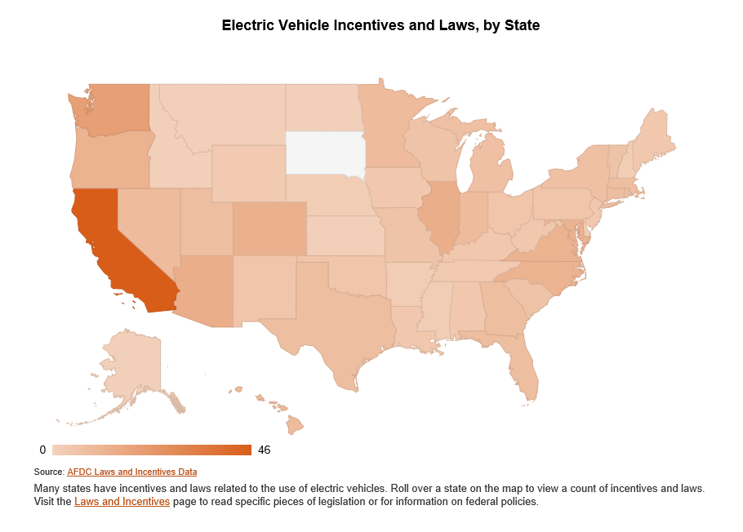

AB 2565 facilitates access to charging stations by requiring commercial and residential property owners to approve installation if the charging station meets requirements and complies with the owner’s process for approving a modification to the property. The law makes a term in a lease of a commercial property, executed, renewed, or extended on or after 1 January 2015, void and unenforceable if it prohibits or unreasonably restricts the installation of an electric vehicle charging station in a parking space.[13]

As of 10 March 2014, a total of 52,264 clean vehicle rebates have been issued, for a total of US$110,222,866 disbursed, with only US$3.8 million remaining for fiscal year 2013-2014. The distribution of the rebates issued correspond to 27,210 [zero-emission vehicles](http://en.wikipedia.org/wiki/California_Air_Resources_Board#California_zero-emissions_vehicle) (ZEVs), including both [battery electric vehicles](http://en.wikipedia.org/wiki/Battery_electric_vehicle) (BEVs) and [fuel cell vehicles](http://en.wikipedia.org/wiki/Fuel_cell_vehicle) (FCVs); 24,657 [plug-in hybrids](http://en.wikipedia.org/wiki/Plug-in_hybrid) (PHEVs); 49 commercial zero-emission vehicles (CZEVs); 210 zero-emission motorcycles (ZEMs); and 138 neighborhood electric vehicles (NEVs).[14] The Clean Vehicle Rebate Project notes their figures do not capture all [plug-in electric vehicles](http://en.wikipedia.org/wiki/Plug-in_electric_vehicle) sold in California because not every PEV owner applies for the rebate

# Customers (February 2014 Survey Report)

The Plug-in Electric Vehicle (PEV) Owner Survey is a long-term collaborative research project managed by Center for Sustainable Energy's (CSE), in coordination with the California Air Resources Board (ARB) and researchers at UT Austin's Lyndon B. Johnson School of Public Affairs and the UC Davis Institute of Transportation Studies.

The latest survey of California’s plug-in electric vehicle (PEV) drivers shows differences in primary purchase motivations from owners of one model to the next. The survey also shows increased satisfaction with public charging options and wider availability of workplace charging.

Previous rounds of the CSE survey consisted largely of all-electric Nissan Leaf drivers. This is the first time drivers of multiple vehicle types have participated: 57% Leaf, 17% Chevrolet Volt and 22% Toyota Prius Plug-in.

The current survey covers drivers who have owned their vehicle for at least six months as of March 1, 2013.

**Highlights from the survey include:**

* The primary motivations for vehicle purchase vary significantly between models – Leaf drivers claimed environment as the primary motivator, Plug-in Prius owners indicate HOV lane access and Volt drivers said fuel savings.
* Chevy Volt-driving respondents are more than four times as likely to have a level 2 charging station installed at their home than Toyota Prius Plug-In respondents.
* Workplace charging availability is becoming more widespread, 46% of respondents reported access to workplace charging, an increase of 14% from March 2012.
* Of those with access to workplace charging, 74% have access to this charging at no cost to the driver, down from 89% in March 2012.
* Though low, driver satisfaction with public charging infrastructure continues to improve, rising from 17% in March 2012 to 29% in May 2013.
* HOV lane access was an extremely or a very important purchase motivation for 59% of respondents; 84% are displaying the HOV lane access sticker.[15]

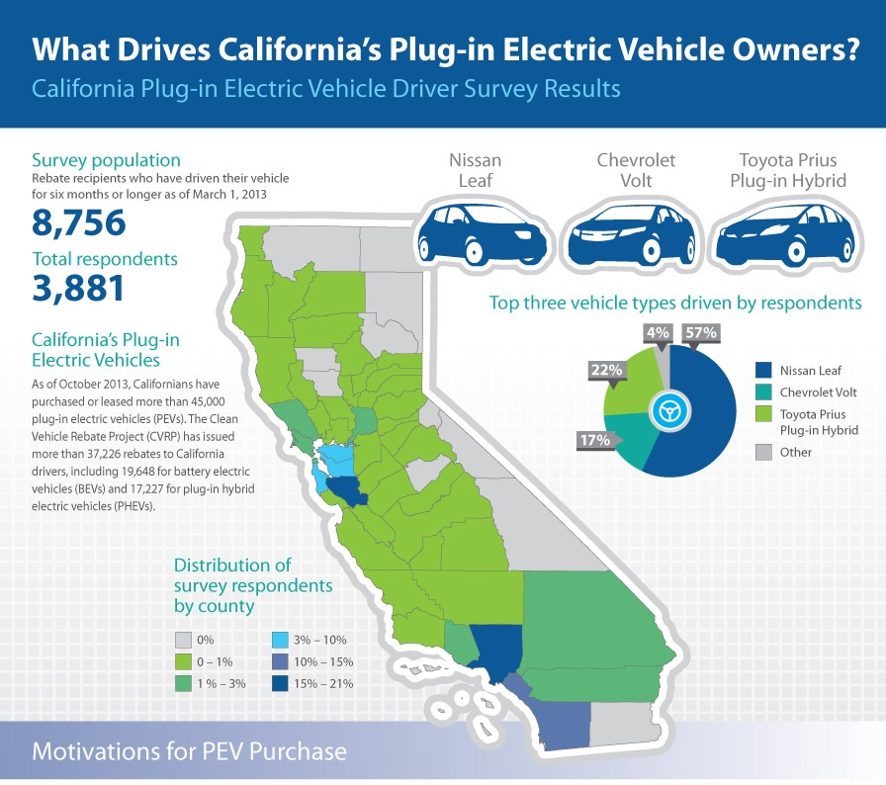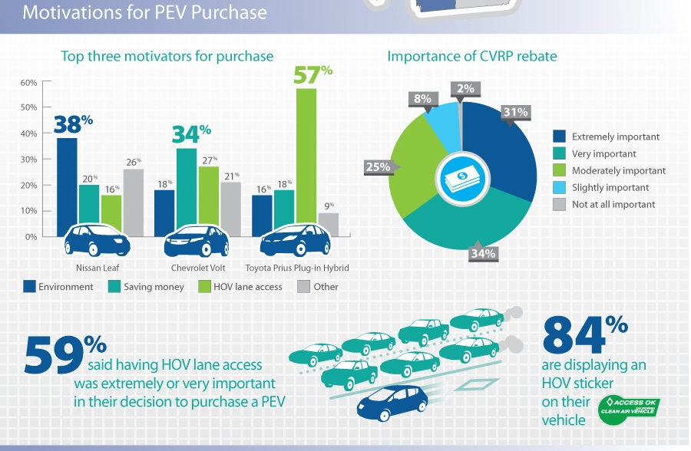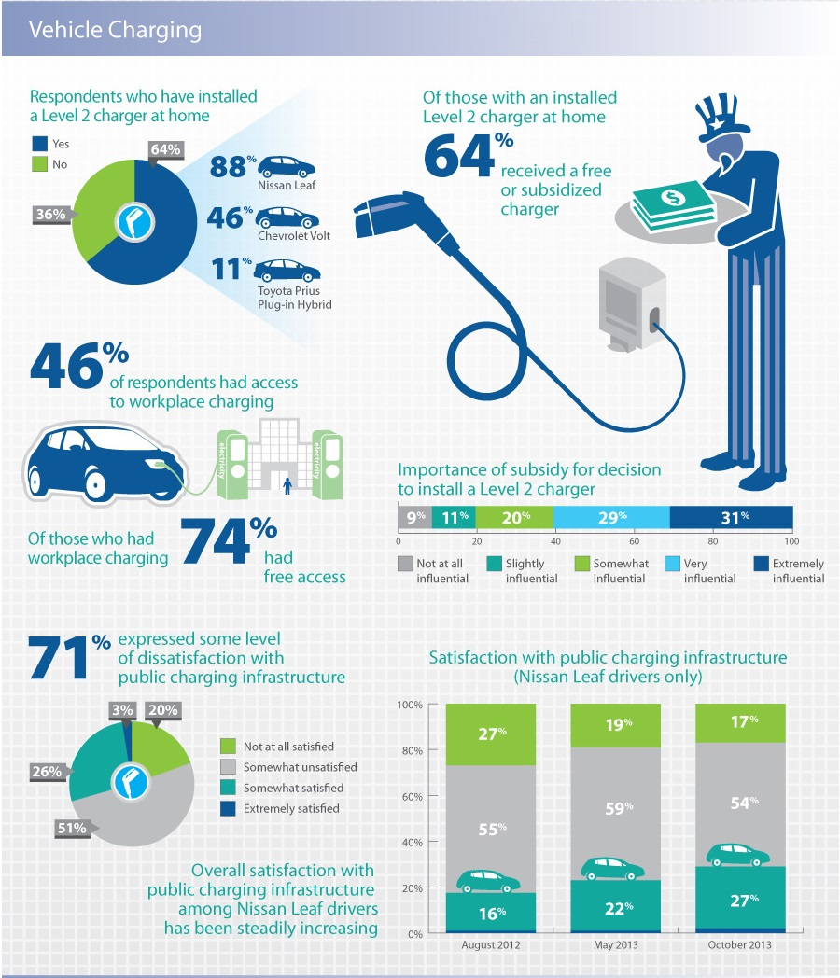

# May 2013 Survey Report

***PEV Owners Highly Satisfied with Driving Experiences***

The latest survey data on how California’s plug-in electric vehicle ( PEV) drivers use and charge their cars indicates that CVRP recipients are highly satisfied with their choice to go electric and use their PEVs as their primary transportation. The study shows PEV owners drive their cars an average of nearly 29 miles per day and charge their vehicles primarily at night when electrical rates are lowest.

California is the nation’s largest PEV market with some 30,000 vehicles, roughly 35 percent of the U.S. total, with sales adding about 2,500 additional cars in the state each month. The data in this survey reflects the actions of some 2,039 PEV owners throughout the state.

**Highlights from the survey include:**

* The CVRP rebate was as an important motivating factor in the purchase decision for 95% of respondents.
* PEV driver satisfaction is high, with 92% of respondents reporting overall satisfaction and driving an average of 910 miles per month.
* Driver satisfaction with public charging infrastructure remains low, but it is improving. Between February and October 2012, satisfaction increased from 17% to 23%.
* Access to workplace charging is available to 37% of survey respondents; however, 66% reported using it less than once per week when charged usage fees.
* For occasional public charging outside the home, two-thirds of respondents reported a willingness to pay up to $1.00 per hour with less than one-third willing to pay $1.50 per hour.
* For daily charging outside the home, only 16% of respondents expressed a willingness to pay up to $1.25 per hour, but 43% were willing to pay $1.00. [16]

[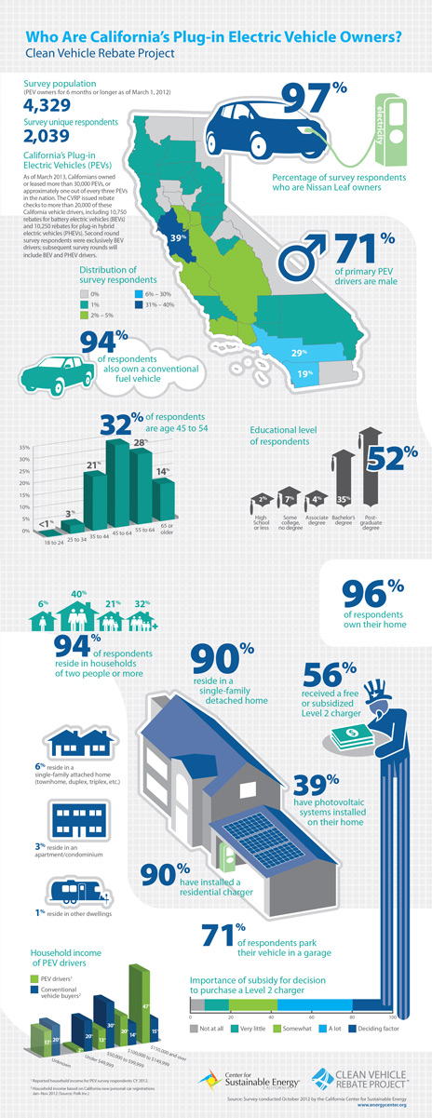](http://energycenter.org/sites/default/files/images/nav/programs/cvrp/infographics/infographic_demographics_2013_vertical.jpg)

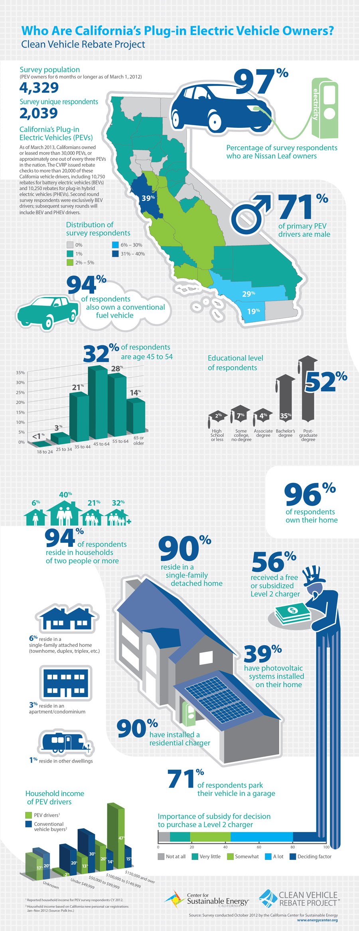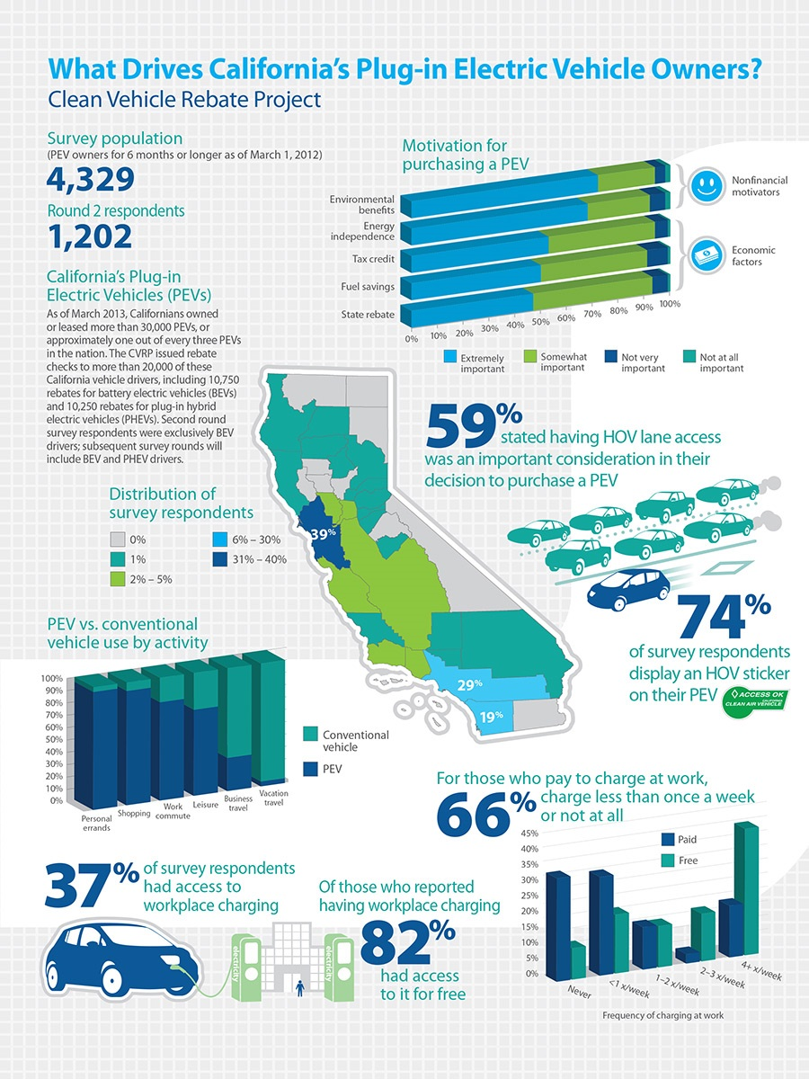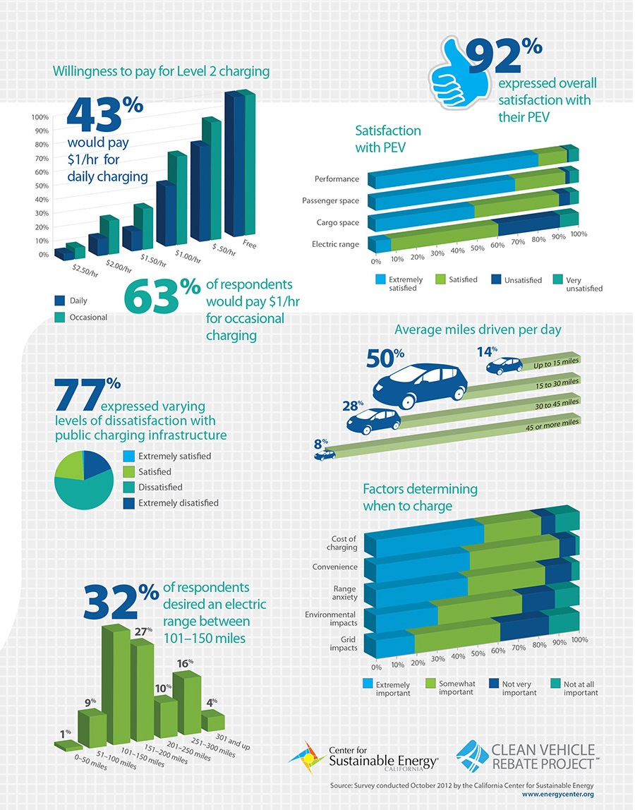

# Discussion[17]

# A Simon Fraser University Faculty of Environment researcher says a new study he conducted with graduate students has important implications for governments with limited budgets to support the electric vehicle market.

[Jonn Axsen](http://www.rem.sfu.ca/people/faculty/jaxsen/), a professor in the School of Resource and Environmental Management, has co-authored a [study](http://www.sciencedirect.com/science/article/pii/S1361920915000103) that finds accessibility to home-based vehicle charging could do more to boost the popularity of electrical vehicles than public chargers.

Working with his graduate students Joseph Bailey, the study’s lead author, and Amy Miele, Axsen found that awareness of public chargers has little impact on consumers’ interest in electrical vehicles.

The researchers recently presented their study to the National Academy of Sciences’ Transportation Research Board in Washington, D.C.

“When we account for the relevant factors, our analysis suggests that the relationship between public charger awareness and plug-in electric vehicle demand is weak or non-existent,” says Axsen. “In other words, the installation of public chargers might not be the best way to encourage growth in the electric vehicle market.

The study collected information from a representative sample of 1,739 new-vehicle-buying households in Canada, with 536 from British Columbia. Respondents were asked about awareness of public charging in their region, and about their overall interest in purchasing a plug-in electric vehicle, such as a Chevrolet Volt or Nissan Leaf.

The data showed that British Columbia’s Clean Energy Vehicle program—which installed almost 500 public chargers when the survey was conducted in 2013—was largely successful in increasing charger awareness. Almost one-third of British Columbian respondents had seen at least one public charger, compared to only 13 per cent of respondents in the rest of Canada.

However, that awareness didn’t necessarily translate into increased plug-in electric vehicle interest.

The study found that future buyers are far more likely to be attracted to plug-in hybrid vehicles, such as the Chevrolet Volt, which can be powered by both gasoline and electricity.

“Since cars such as the Chevy Volt don’t rely only on electricity, potential buyers aren’t concerned about public charging,” says Bailey. “People can just recharge at home, and then drive wherever they want on any given day. The good news is that about two-thirds of car buyers already have some type of charging access at home.”

Purchase rebates also spark consumer interest

“Given what we’ve seen here, it seems wise for governments to focus their money on incentives other than public electric vehicle chargers,” says Axsen. “We know that purchase rebates can spark consumer interest, and we’ve shown that home charging is important. In combination with the implementation of a Zero Emissions Vehicle mandate like California’s, these measures could be the biggest boosters of electric vehicle sales.”

Grants provided by the Social Sciences and Humanities Research Council of Canada, and Natural Resources Canada funded this research.

# **Bibliography**

1. <http://en.wikipedia.org/wiki/Plug-in_electric_vehicles_in_the_United_States#California>
2. <http://www.autoblog.com/2013/04/10/us-public-charging-stations-increase-by-9-in-first-quarter/>
3. <http://www.afdc.energy.gov/fuels/stations_counts.html>
4. <http://gov.ca.gov/news.php?id=17463>
5. <http://energycenter.org/clean-vehicle-rebate-project>
6. <http://www.hybridcars.com/californians-bought-more-plug-in-cars-than-china-last-year/>
7. <http://www.cncda.org/CMS/Pubs/Cal_Covering_4Q_14.pdf>
8. <http://www.navigantresearch.com/newsroom/nearly-1-in-4-plug-in-electric-vehicles-sold-in-the-united-states-from-2012-to-2020-will-be-sold-in-california>
9. <http://energy.gov/eere/vehicles/vehicle-technologies-office>
10. <http://www.its.ucdavis.edu/research/publications/publication-detail/?pub_id=2353>
11. <http://www.eia.gov/todayinenergy/detail.cfm?id=19131>
12. <http://www.electric-vehiclenews.com/2014/11/electric-vehicles-account-for-almost-10.html>
13. <http://www.hybridcars.com/california-leads-the-way-in-electric-vehicle-sales/>
14. <http://www.afdc.energy.gov/case/2023>
15. <http://energycenter.org/clean-vehicle-rebate-project/vehicle-owner-survey/july-2012-survey>
16. <http://energycenter.org/clean-vehicle-rebate-project/vehicle-owner-survey/cvrp-final-report-2012-2013>

1. Jeff Cobb (2014-10-22). ["Global Plug-in Car Sales Now Over 600,000"](http://www.hybridcars.com/global-plug-in-car-sales-now-over-600000/). HybridCars.com. Retrieved 2014-10-23. *Cumulative global sales totaled 603,932 highway legal plug-in electric passenger cars and light utility vehicles through September 2014, consisting of 356,232 all-electric cars and utility vans and 247,700 plug-in hybrids. Sales figures account for sales only in the top ten world's markets.*
2. Dana Hull (2014-09-08). ["California charges ahead with electric vehicles"](http://www.mercurynews.com/business/ci_26493736/california-charges-ahead-electric-vehicles). [*San Jose Mercury News*](http://en.wikipedia.org/wiki/San_Jose_Mercury_News). Retrieved 2015-03-15
3. <http://www.hybridcars.com/californians-bought-more-plug-in-cars-than-china-last-year/>
4. <http://www.hybridcars.com/market-dashboard/>
5. <http://www.hybridcars.com/californians-bought-more-plug-in-cars-than-china-last-year/>
6. Nathan Bomey (2012-06-05). ["California can't get enough of the Chevy Volt as sales surge"](http://www.freep.com/article/20120605/BUSINESS01/206050424/California-can-t-get-enough-of-the-Volt-as-sales-surge). [*Detroit Free Press*](http://en.wikipedia.org/wiki/Detroit_Free_Press). Retrieved2012-06-06.
7. Staff (2012-03-23). ["Governor Brown Announces $120 Million Settlement To Fund Electric Car Charging Stations Across California"](http://gov.ca.gov/news.php?id=17463). Office of Governor Edmund G. Brown Jr. Retrieved2014-09-22
8. Angelo Young (2014-09-02). ["Tesla Motors' Tesla Model S Is Outselling Nissan Leaf In Northern European Markets"](http://www.ibtimes.com/tesla-motors-tesla-model-s-outselling-nissan-leaf-northern-european-markets-1676018).[*International Business Times*](http://en.wikipedia.org/wiki/International_Business_Times). Retrieved 2014-09-21.
9. [U.S. Department of Energy](http://en.wikipedia.org/wiki/U.S._Department_of_Energy) (2013-12-25). ["Alternative Fueling Station Counts by State"](http://www.afdc.energy.gov/fuels/stations_counts.html). Alternative Fuels Data Center (AFDC). Retrieved 2013-12-31. *The AFDC counts electric charging units or points, or EVSE, as one for each outlet available, and does not include residential electric charging infrastructure*.
10. ["Clean Vehicle Rebate Project FAQ: Changes in CVRP FY 2011-2012"](https://energycenter.org/index.php/incentive-programs/clean-vehicle-rebate-project/frequently-asked-questions-cvrp#changes). Center for Sustainable Energy California. Retrieved2011-05-22.
11. [California Department of Motor Vehicles](http://en.wikipedia.org/wiki/California_Department_of_Motor_Vehicles) (March 2014). ["Clean Air Vehicle (CAV) Decals - High Occupancy Vehicle HOV Lane Usage"](http://www.dmv.ca.gov/vr/decal.htm). DMV California. Retrieved 2014-03-23.
12. Melanie Mason and Patrick McGreevy (2014-09-21). ["Gov. Jerry Brown signs bills to boost purchases of electric cars"](http://www.latimes.com/local/political/la-me-pc-brown-electric-vehicles-20140921-story.html). [*Los Angeles Times*](http://en.wikipedia.org/wiki/Los_Angeles_Times). Retrieved 2014-09-21.
13. Marisa Lagos (2014-09-22). ["Brown signs several clean-air vehicle bills"](http://www.sfgate.com/bayarea/article/Brown-signs-several-clean-air-vehicle-bills-5771184.php). [*San Francisco Chronicle*](http://en.wikipedia.org/wiki/San_Francisco_Chronicle). Retrieved2014-09-22.
14. [Clean Vehicle Rebate Project](http://en.wikipedia.org/wiki/Clean_Vehicle_Rebate_Project) (2014-03-10). ["Clean Vehicle Rebate Project Statistics"](http://energycenter.org/clean-vehicle-rebate-project/cvrp-project-statistics). California Center for Sustainable Energy. Retrieved 2014-03-23.
15. <http://energycenter.org/clean-vehicle-rebate-project/vehicle-owner-survey/feb-2014-survey>
16. http://energycenter.org/clean-vehicle-rebate-project/vehicle-owner-survey/may-2013-survey
17. <https://www.sfu.ca/sfunews/stories/2015/electric-vehicles-success-not-tied-to-public-chargers.html>